Cumulative Activity Opinion Piece - How I will organize my work

My Topic
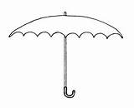
__________________________________________________________________________________________________________________________________________________________________________________________
What are my thoughts on what I am planning on doing?

My Opinion Piece My Media Piece My Presentation Piece
______________________________________________________________________________________________________________________________________________________________________________ | ______________________________________________________________________________________________________________________________________________________________________________ | ______________________________________________________________________________________________________________________________________________________________________________

How my pieces are linked:

My Opinion Piece My Media Piece My Presentation Piece
_______________________________________________________________________________________ | _______________________________________________________________________________________ | _______________________________________________________________________________________

DUE DATE-Thursday,November 20th, 2014

